* **Positive example: *Tapo***
  + follows the principle “content on top”:

toolbars at the bottom, no problem, since there is no system controls

content at the center, inside the thumb zone

data modification controls (‘plus’ button) positioned outside the thumb zone, at the top-right corner

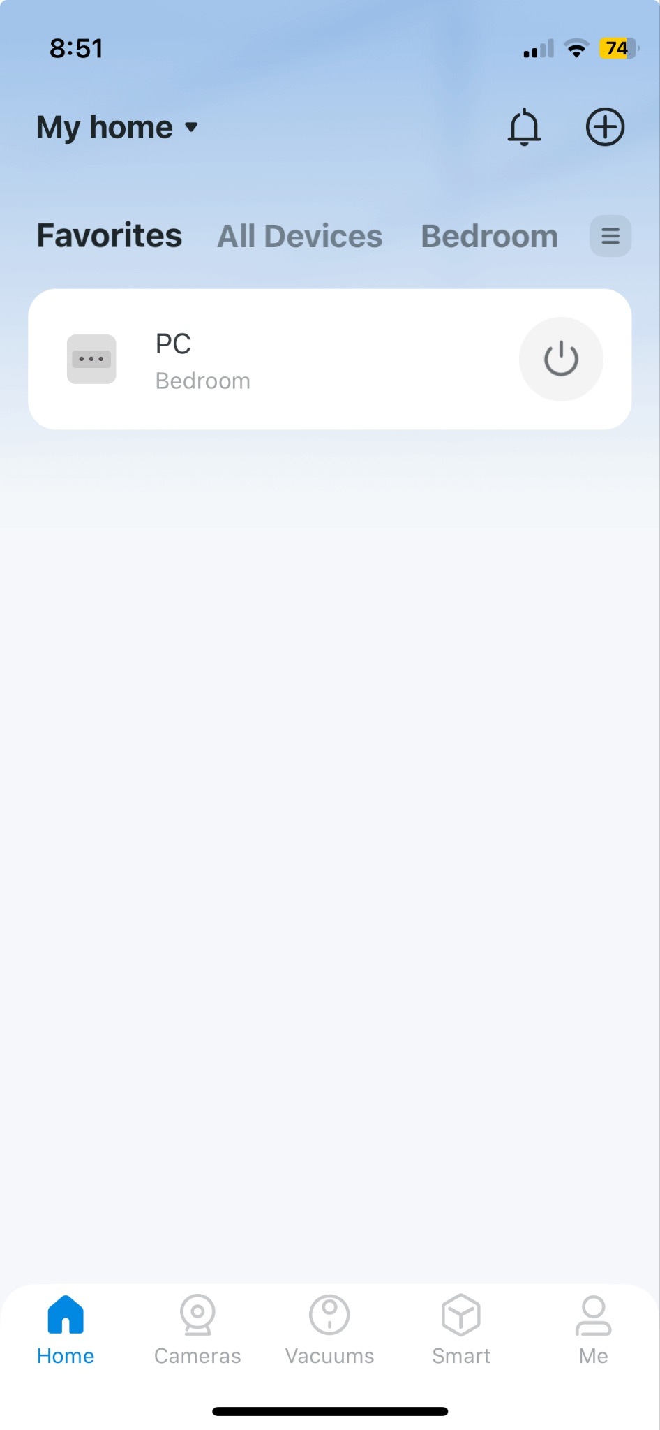

* + Just-in-time interfaces (?)
    - Not tap (since this action adding no new informations), but swipe gesture to change between the pages (‘Favorites’ - ‘All Devices’ - ‘Bedroom’);
    - Tapping on a device, following the *progressive disclosure*, will be shown more details about it, in addition, also the button ‘Show more’ follows this principle
    - There is also the swipe gesture to come back to homepage, without needing to tap the button positioned in the top-left corner

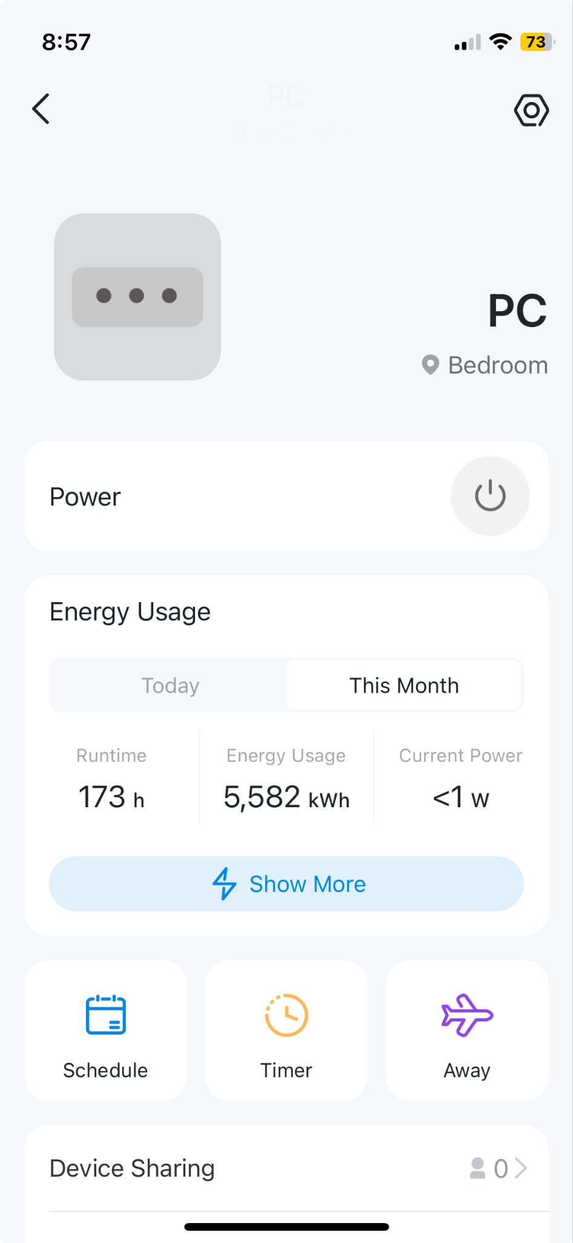

**NEGATIVE DESIGN: ITALO**

**- NEGATIVE ASPECTS**

Homepage:

* **CAROUSEL MANAGEMENT**: carousel components should be avoided if possible because they cause the loss of the overall vision and users do not know what comes before and next. This carousel is static which is a good thing because every user can read the content without caring about timers but, on the other hand, users are forced to do a lot of swipes to find the information. Furthermore, it is not possible to know when we have reached the end of the carousel since when you arrive at the last slide and you try to go on, infinite copies of that slide are shown every time you make another right swipe so without arriving at the end of the carousel. This can frustrate users.
* **CONFLICT WITH OS GESTURES**: it is possible to open the hamburger menu in two ways: tapping on the top-left icon or using a flick gesture (quickly brush surface with fingertip) from the left border to the right. The last one option is problematic since the movement works only if we start the action in the highlighted red box area, not before or after that zone. Since gestures by definition should not require high precision and, day by day, they become a sort of reflexes this is problematic. If we do not start the movement from this small area the gesture fails or the OS manages the movement as a “go back” option that can even close the app if we are in the homepage, creating so much frustration in users.

Android gestures source:

<https://www.androidpolice.com/how-to-use-gesture-navigation-on-android/#:~:text=How%20to%20use%20Android%E2%80%99s%20gesture%20navigation>

My Profile:

* **LOSS OF THE BOTTOM MENU IN INTERNAL PAGES**: there is to note that every time we open an internal page the bottom menu, containing the main app functionalities and pages, disappears. This in fact can make the users’ experience more stressful because every time a user wants to visit another page is forced to go back to the homepage using the “go back option” (top-left arrow) or opening the hamburger menu with the previously discussed limitations.
* **DANGEROUS OPERATIONS IN THE COMFORT ZONE**: there is a problem in the “Profile” page and in its subpage “Profile Data”, both logout button and delete account button are placed in the comfort zone, this can represent a potential problem since these operations are potential dangerous so they should be both placed outside the comfort zone avoiding so dangerous taps.

**+ POSSIBLE SOLUTIONS**:

* CAROUSEL MANAGEMENT **🡪** use (a list of) buttons that provide different entry points (for more detailed pages) on which users can tap if interested, this avoid to explore the content of the carousel through many swipes.
* CONFLICT WITH OS GESTURES 🡪 since the Italo gesture is overlapped with the OS one, a possible solution could be just removing the gesture option and let the users tap on the menu button to explore its content.
* LOSS OF THE BOTTOM MENU IN INTERNAL PAGES 🡪 it should appear in every page of the application, in this case users’ experience is less stressful.
* DANGEROUS OPERATION IN THE COMFORT ZONE 🡪 most dangerous operations should be put outside the comfort zone in order to avoid mistakes by users.